PATCH (Palliation and The Caring Hospital)
(Scottish Charitable Organisation SCO44231)
Charity Cards 2021
£8 for a pack of 10

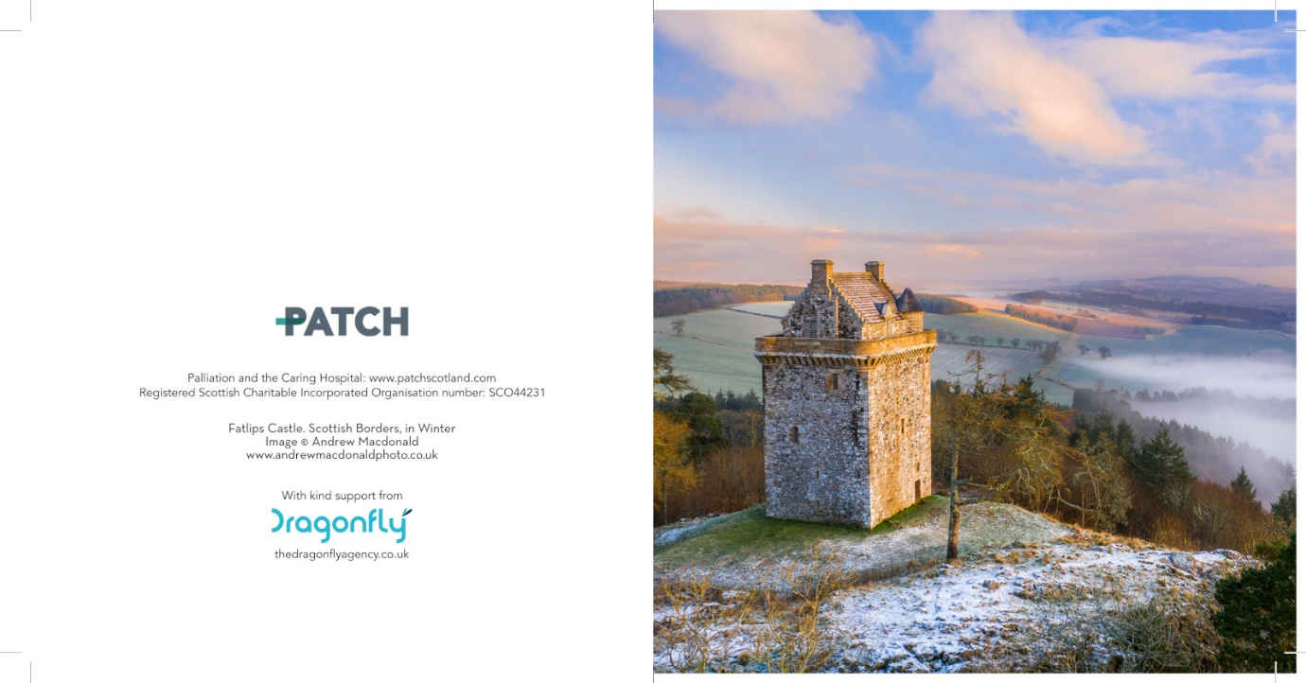

This year’s card will have special appeal to many people. The atmospheric image of Fatlips Castle in the Scottish Borders was captured by talented Ancrum photographer, Andrew Macdonald.
The cards are blank inside so can be used for Festive Season Greetings and as notelets throughout the year.
As all costs of production have been very generously sponsored by the Dragonfly Agency in Edinburgh, all proceeds of sales will be available to support the work of our charity. More information about PATCH is accessible at www.patchscotland.com

Please complete the order form below and return to me with your remittance.
Thank you for your interest and support.

Dr Gordon Paterson
Director (PATCH)

PATCH Charity Cards 2021
Order Form

Name: ………………………………………………………………………………………….

Address: …………………………………………………………………………………..
…………………………………………………………………………………..
……………………………………………………………………………………
…………………………………………………………………………………….

Postcode: ………………………………..

e-mail address:…………………………………………………………………………

Telephone number: …………………………………………………………………..

Please supply ……. packs of 10 cards at £8 per pack. Cost £ …….

Contribution to mailing costs where appropriate (optional) £…..
Total cost: £………
Please make cheques payable to PATCH
Please return completed order form with remittance to
Dr Gordon Paterson
Director (PATCH)
Heatherlands
Ancrum
Jedburgh TD8 6XA

Receipt of order and remittance will be confirmed by e-mail.

